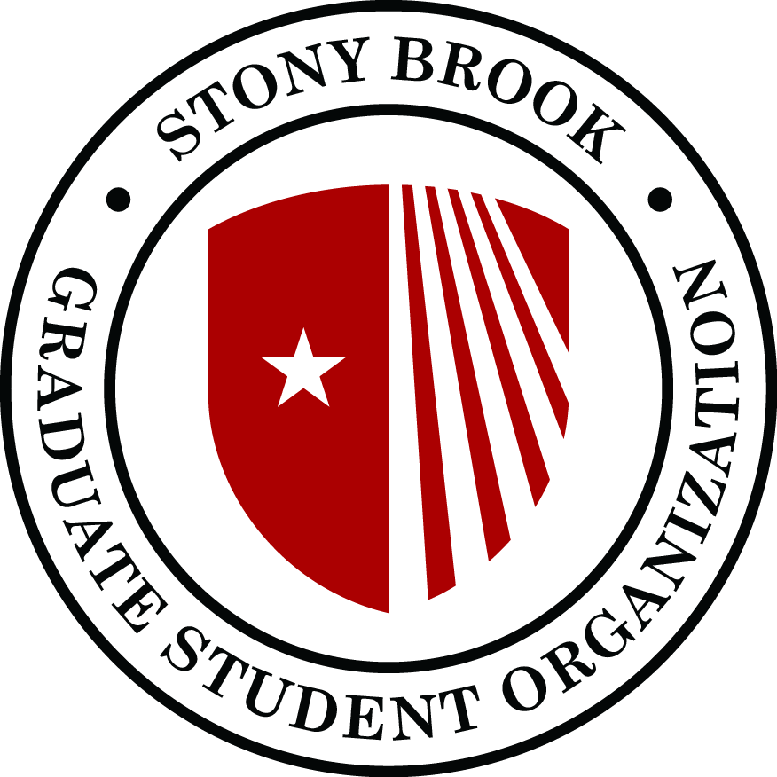
Graduate Student Organization
Senate Meeting
Agenda
November 11, 2019
SAC 302 @ 5-7p.m.

- Call to order:
- Adoption of the Agenda
- Approval of minutes from previous senate meeting:
- Guest speakers:
  - Shafeek Fazal and Heath Martin, SBU Libraries
- President’s Report:
  - Status on the grad lounge and bar
  - Graduate student writing support: Dissertation Bootcamp and Writing Group program
  - LIRR negotiations to have a reduced rate for SBU students
  - Organized DC advocacy trip on higher education issues and climate change and environment
  - Organized meeting with governor Cuomo’s staff

- Vice-president’s Report:
  - Production
  - Fees
- Treasurer’s Report:
- Secretary’s Report:
  - Approval of committee membership. Please refer to this list.
- Speaker’s Report
  - Legal Clinic
  - DTA
- PAC Report:
- Advocacy trip to D.C.
- Upcoming meeting with governor Cuomo and representative Zeldin’s respective staff.
- Update on Elsevier situation
- ISA Report:
- Unfinished business:
- New business:
- Announcements:
- Adjournment:

