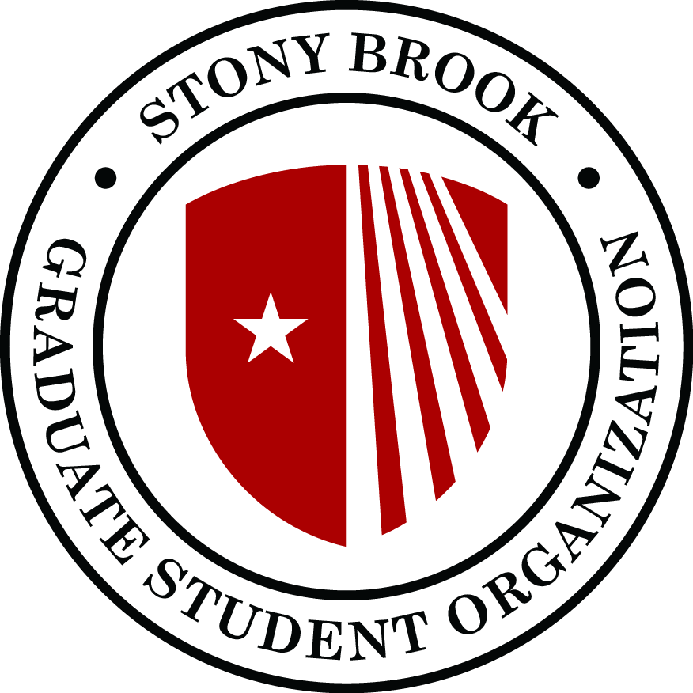
Graduate Student Organization
Senate Meeting
Agenda
October 8, 2019
SAC 302 @ 5-7p.m.

- Call to order
- Adoption of the Agenda
- Approval of minutes from previous senate meeting:
- Guest speakers:
  - Debra Scarfogliero - Stony Brook Child Care Services
  - Alfreda James - Career Center
  - Jarvis Watson - SBU Chief Diversity Officer
- President Report:

- Vice-president Report:
  - Events
  - Fees
- Treasurer Report:
  - New positions on GSO staff :
    - Social Media Coordinator
    - Events Assistant
  - Social / Cultural Events and Speaker Series approved by Budget committee
- Secretary Report:
  - Approval of new committees:
    - DTA
    - Graduate Council: Jordan Young, Abraham Kohrman
    - Executive Council - University Senate: Camilo Rubbini
    - FSA Board of Directors: James Vassallo
    - Alumni Association Board: Xiaoqing Zhang
    - Committee for Academic Planning and Resource Allocation (CAPRA): Xiaoqing Zhang
    - CAS undergraduate curriculum: EMPTY
    - Child Care Board: EMPTY

  - Committees:
Committee | Chair
Academic Affairs (CAA) | Speaker
Board of Appeals | Secretary
Budget | Treasurer
Disability Advocacy/ADA Working Group (Dean of Students) | Abraham Kohrman
Distinguished Travel Award (DTA) | Speaker
Elections | Secretary
Graduate Student Emergency Loan Fund (GSELF) | Grad Advocate
GSEU Liaison | Anna McPherran
Housing | John Klecker
International Student Affairs | ISA
Policy Action | PAC
RA Union Liaison | Chikako Takahashi
Rules and Constitution | Speaker
Social Concerns | Vicepresident
Student Fee Advocacy | Vicepresident
  - Task delegation for committees:
    - Academic Affairs: Creation of a code of ethics/conduct for departments that want to participate. Purpose: deal with grievances between advisors and advisees, and especially guidelines for co-authorship; interested departments: Ecology and Evolution; History. This is so that there is a more unified code among departments.
    - Disability Advocacy: With ISA; create a survival guide equivalent for students with disabilities. This should help them be able to navigate campus resources.
    - Rules and Constitution:
      - amend constitution as approved in September Senate Meeting
      - Draft proposal amendment to elect speaker of the senate during may senate meeting.
  - Senate meeting schedule and changes to november senate meeting.
    - Proposed to have senate meetings on different days of the week so that if people can’t come at a fixed time, they can come to some of the others.
    - November meeting: Need to reschedule to Monday Nov 11: part of the board will be in DC, part will be in Albany for advocacy.

- PAC Report:
- ISA Report:
- Unfinished business:
- New business:
- Announcements:
- Adjournment:

